**Guidance on How to Create an Account & Register the Program on the China Intellectual Property E-learning Platform**

**Step 1**:

Please click the following link “ *international.ciptc.org.cn* ”, it will direct you to the homepage of the China Intellectual Property E-learning Platform.

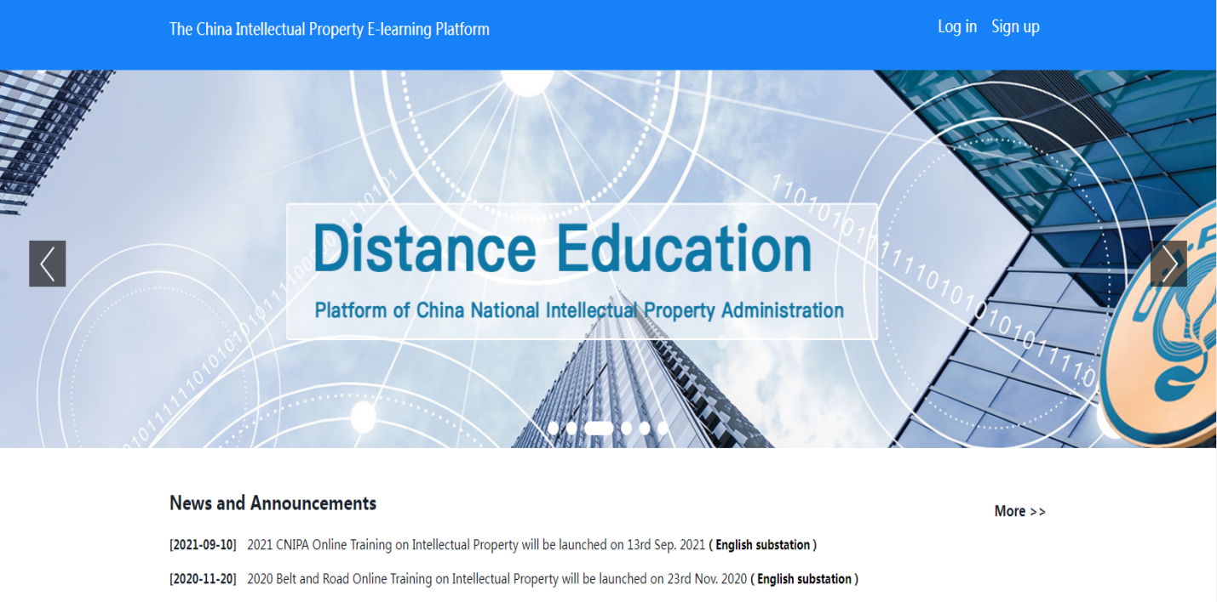

**Step 2**:

Please click “Sign up” to start to create an account.

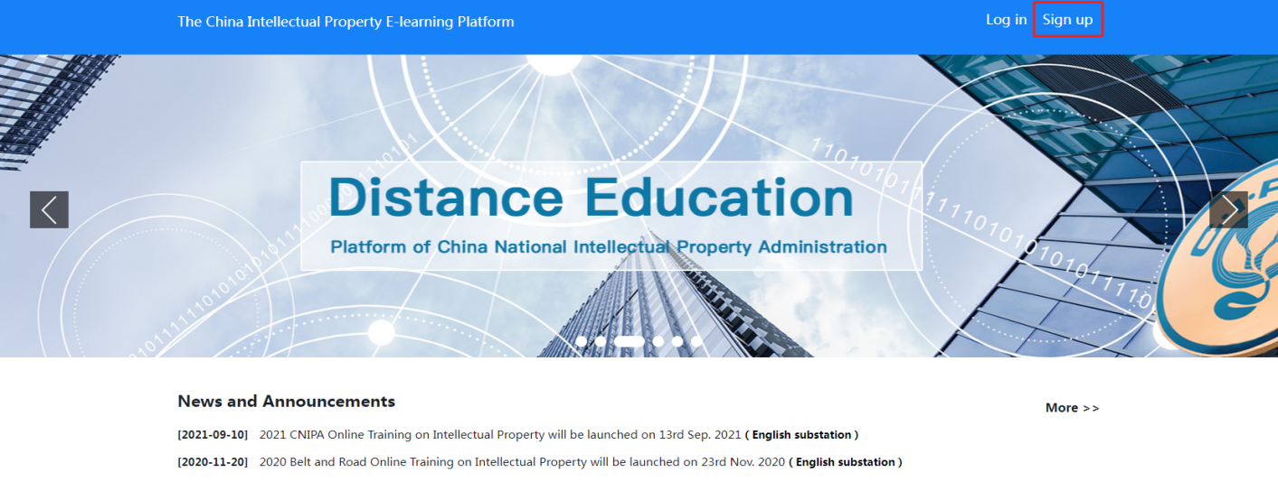

**Step 3**:

Please follow the instructions on the interface to set your user name, password and verification code (if the code expired, please click the code in the gray frame again).

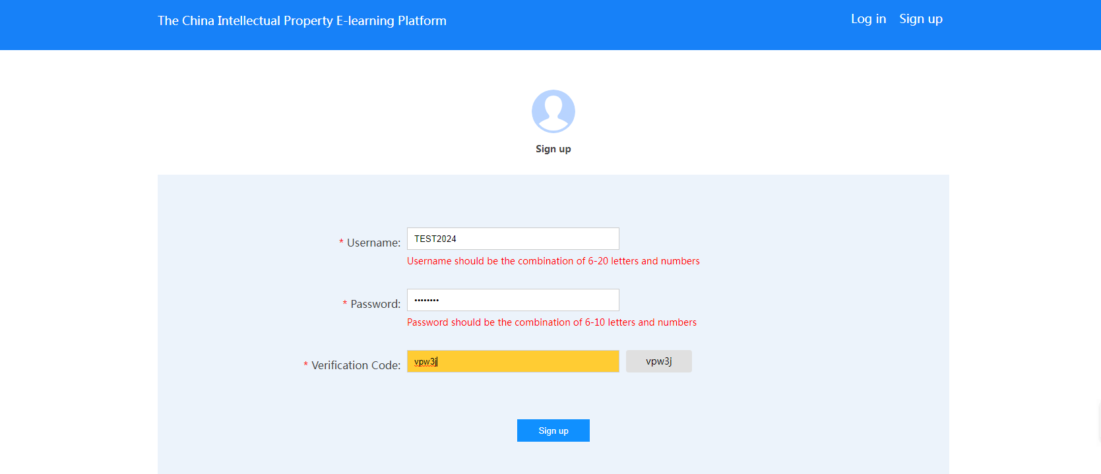

**Step 4**:

The system will notify you with a pop-up window on whether your account has been created or not.

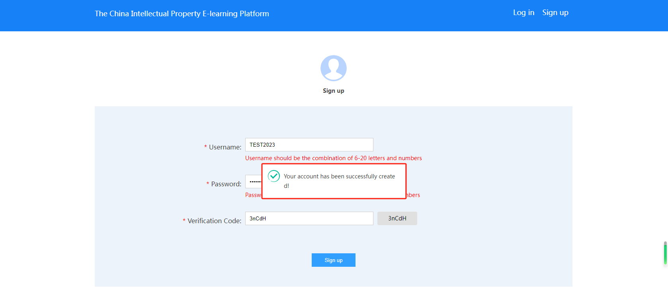

**Step 5**:

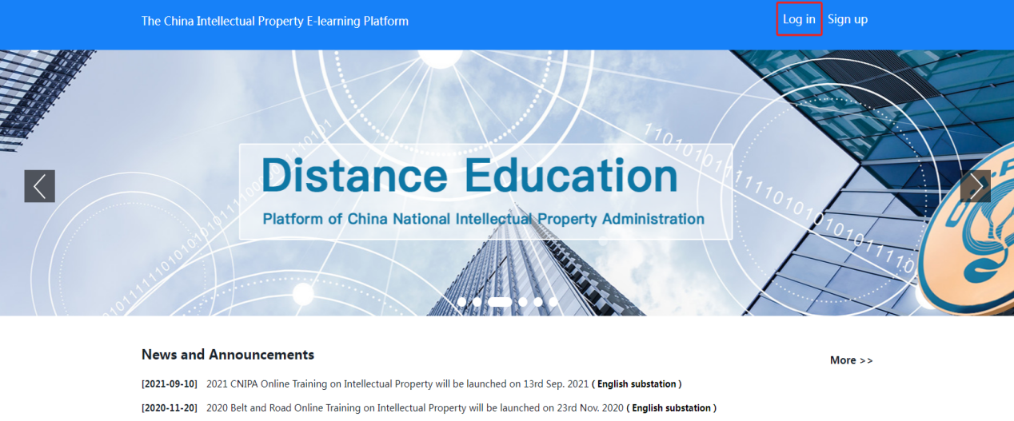The system will direct you to the homepage of the platform, please click “Log in”.

**Step 6**:

Please enter the username, password you successfully created earlier, and enter the verification code (if the code expired, please click the code in the gray frame again).

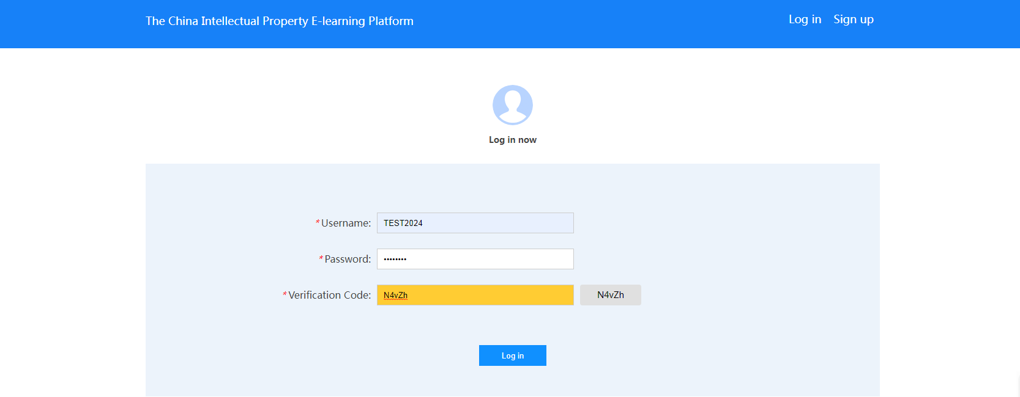

**Step 7**:

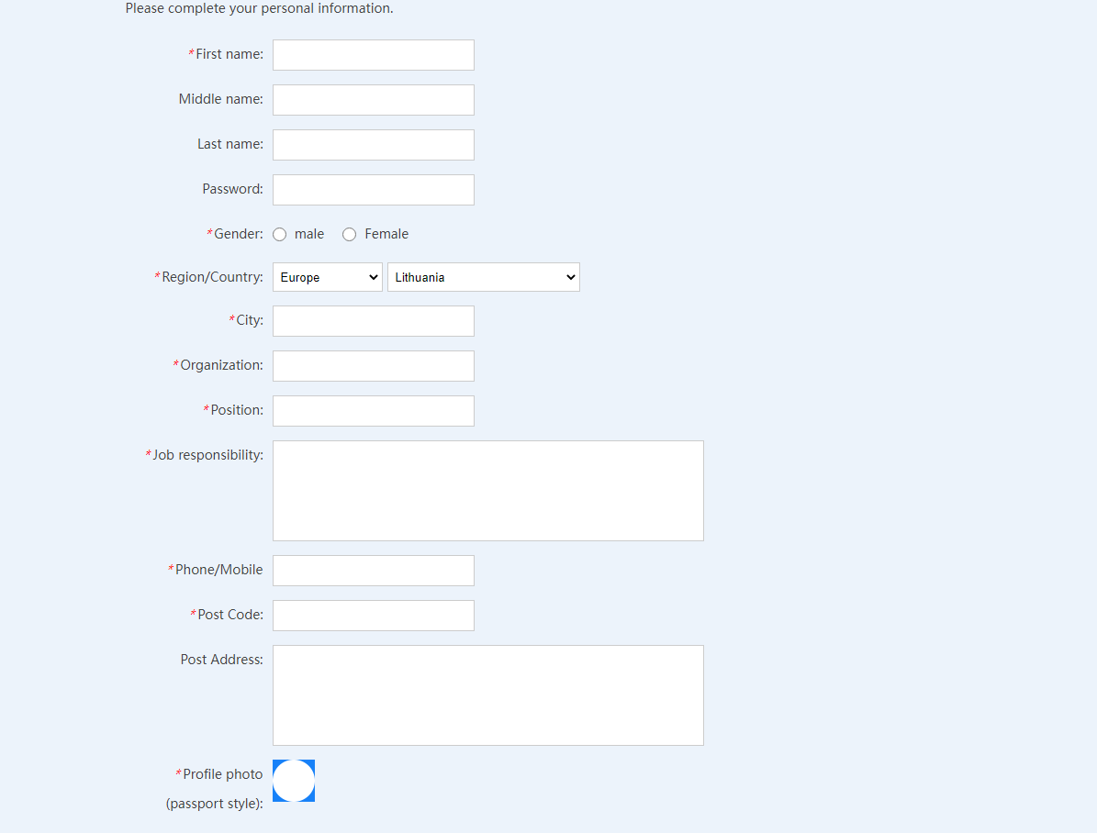Please complete your personal information before sign up for the program (profile photo is preferably submitted in passport style).

**Step 8**:

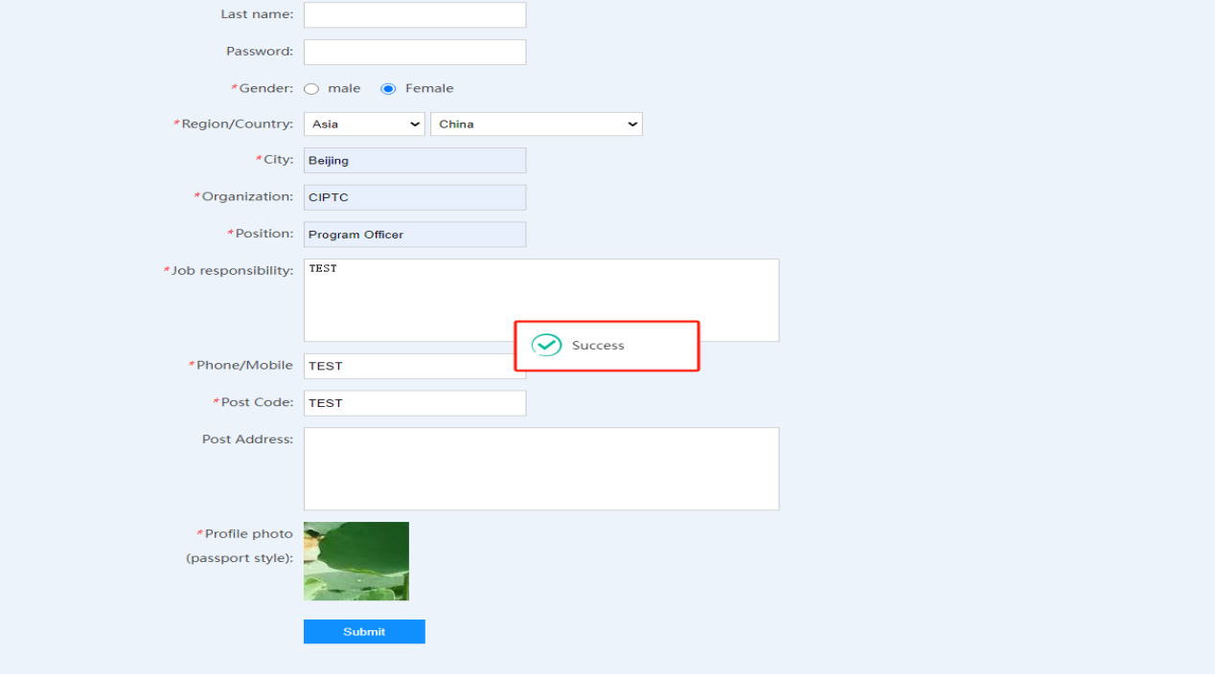Once you finished filling in all the required information, please click “submit”. The system will notify you with a pop-up window on whether your account has been finally created or not.

**Step 9**:

After logged in your account, please open the homepage of the China Intellectual Property E-learning Platform. Please click the “2025 BRIPC IP Capability Online Training Program for IP Practitioners (Basic Course I)” section to sign up for the courses of the program.

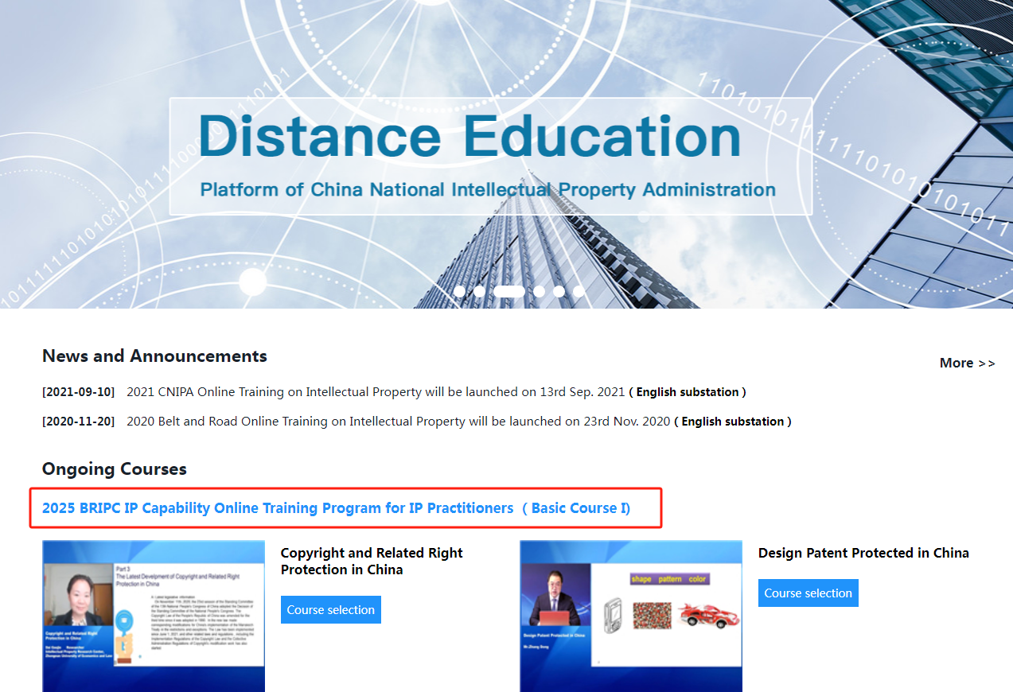

**Step 10**:

Please click “Course selection” to sign up for the courses under this program.

