Guidance on How to Create an Account & Register the Program on the China Intellectual Property E-learning Platform

Step 1:
Please click the following link “ international.ciptc.org.cn ”, it will direct you to the homepage of the China Intellectual Property E-learning Platform.


Step 2:
Please click “Log in” on this webpage.



Step 3:
The system will direct you to this webpage, please click “Create New Account”.

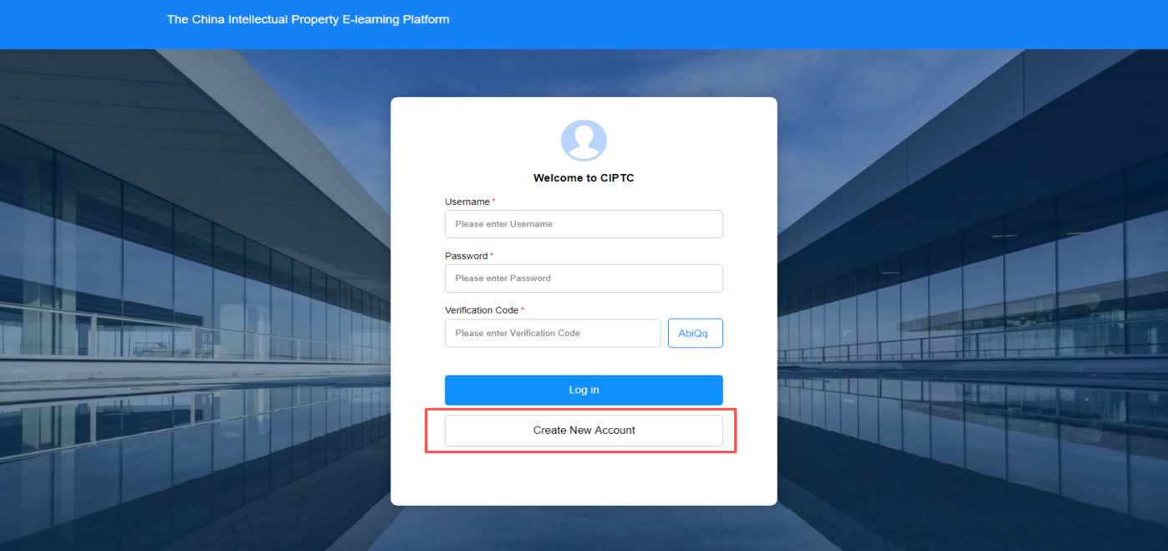

Step 4:
Please follow the instructions on the interface to set your user name, password and verification code (if the code expired, please click the code in the blue-line square frame again), then please click “Sign up”.

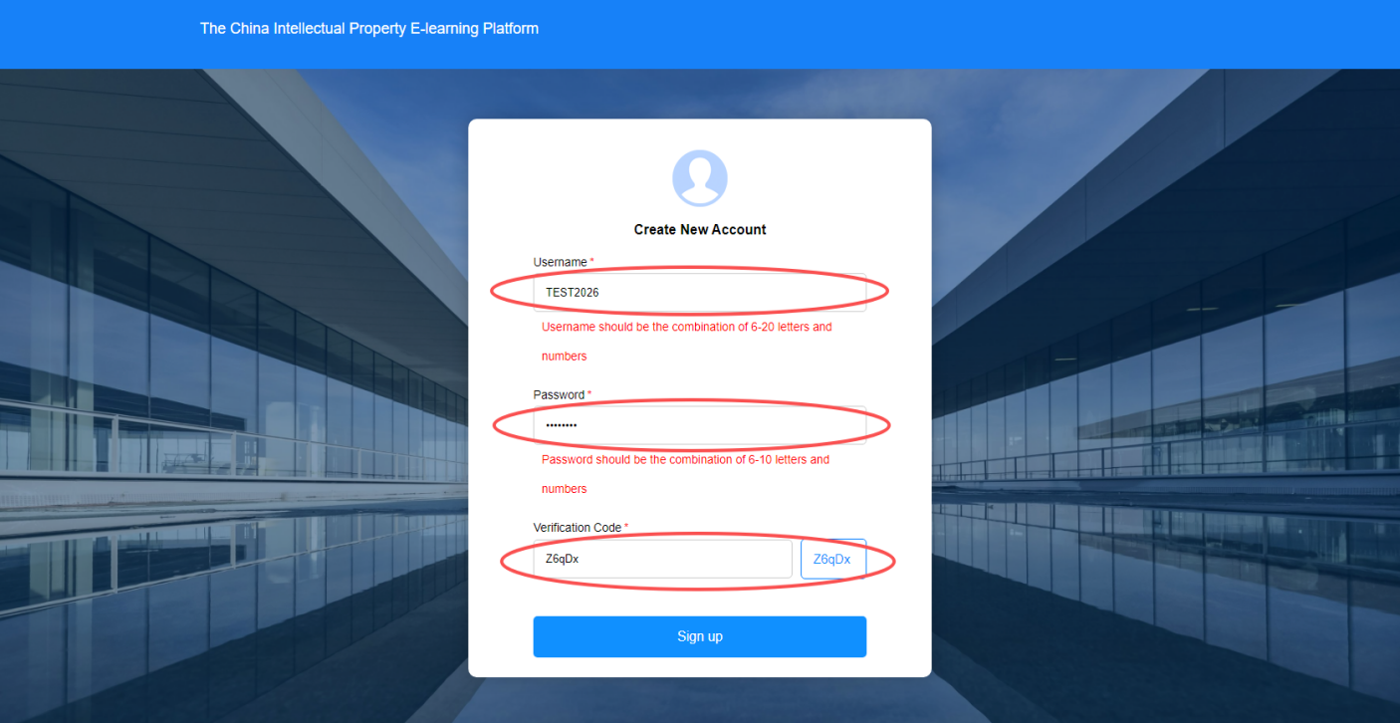

Step 5:
The system will notify you with a pop-up window on whether your account has been created or not.

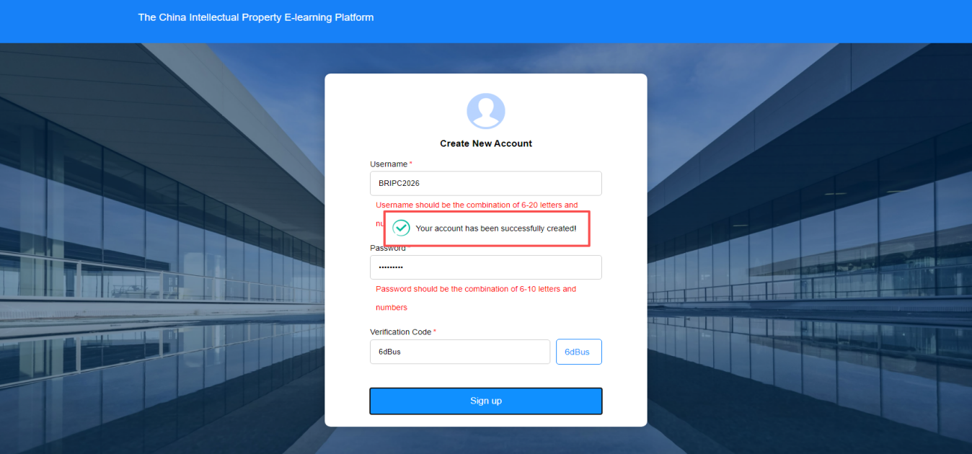

Step 6:
The system will then direct you to the homepage of the platform, please click “Log in”.

Step 7:
Please enter the username, password you successfully created earlier, and enter the verification code (if the code expired, please click the code in the blue-line square frame again).
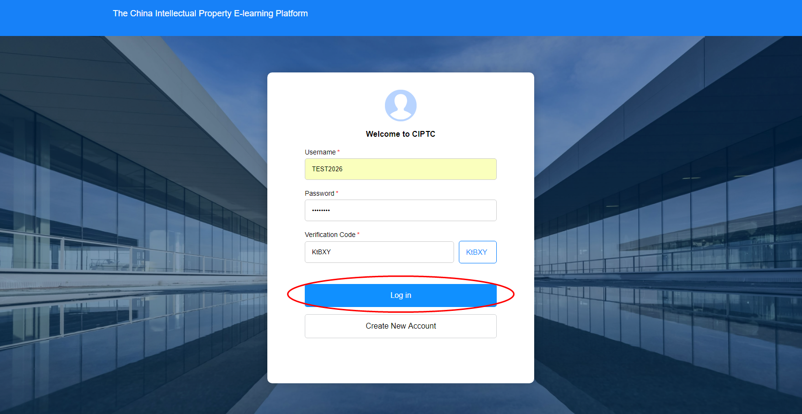
Step 8:
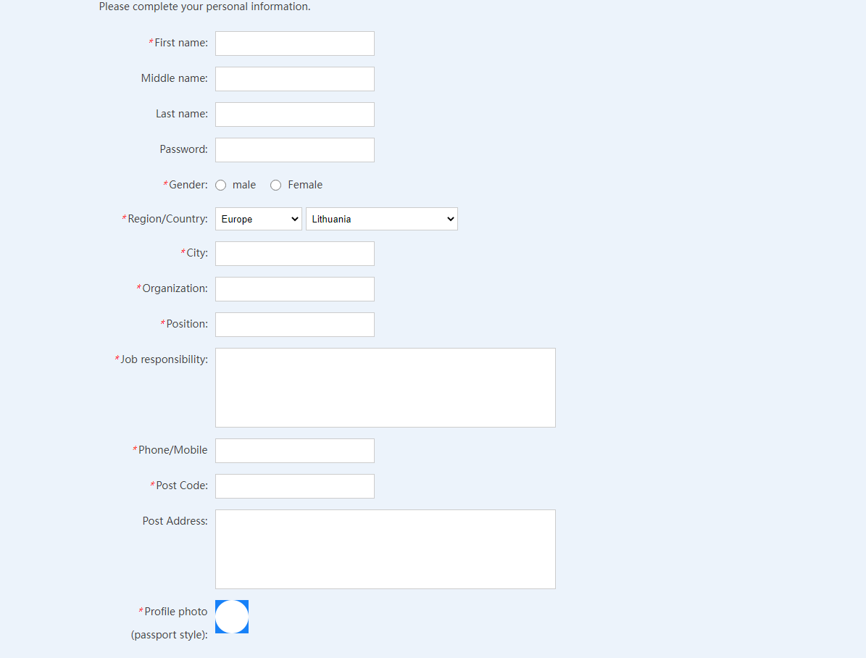
Please complete your personal information before sign up for the program (profile photo is preferably submitted in passport style).

Step 9:
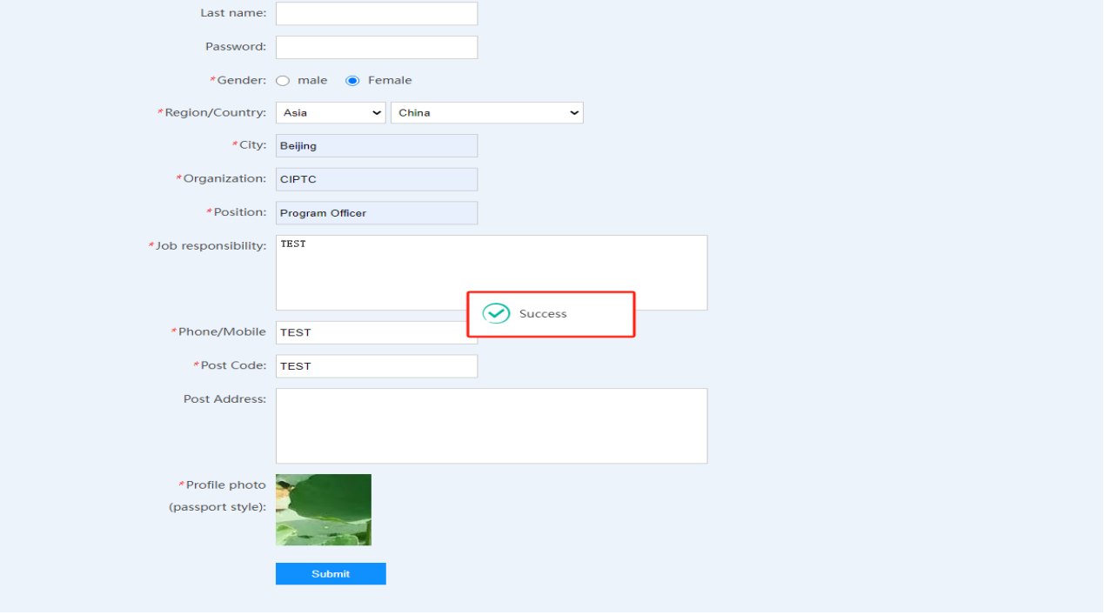
Once you finished filling in all the required information, please click “submit”. The system will notify you with a pop-up window on whether your account has been finally created or not.

Step 10:
After logged in your account, please open the homepage of the China Intellectual Property E-learning Platform. Please click the “2026 BRIPC IP Capability Online Training Program for IP Practitioners” section to sign up for the courses of the program.
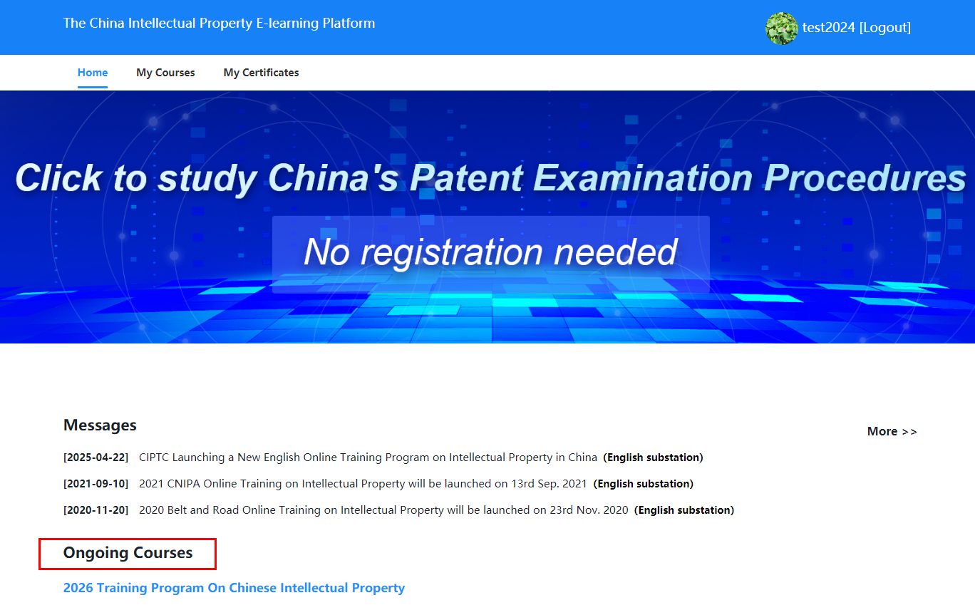

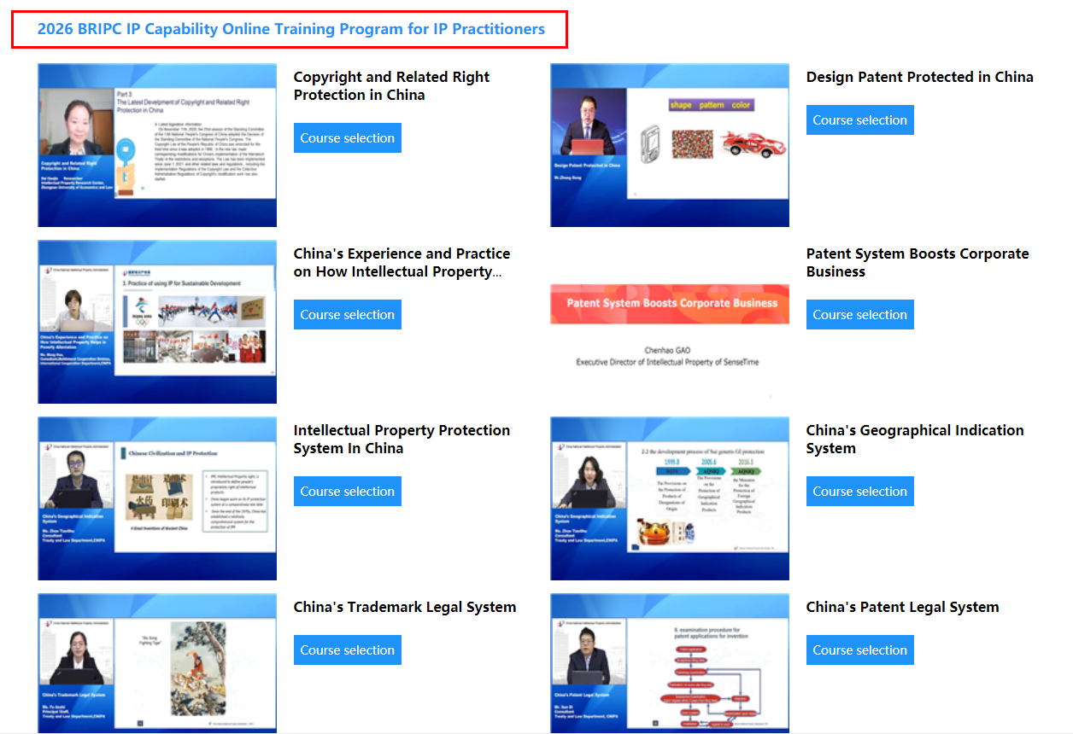
Step 11:
Please click “Course selection” to sign up for the courses under this program.
